SET-2
Regulations:
A18

H.T No

Sreenidhi Institute of Science and Technology
(An Autonomous Institution)
Code No: 7F302 Date: 16-Dec-2019 (FN)

B.Tech II-Year I-Semester External Examination, Dec-2019/Jan-2020 (Regular)
DISCRETE MATHEMATICS (IT)

Time: 3 Hours Max.Marks:70

Note: a) No additional answer sheets will be provided.
b) All sub-parts of a question must be answered at one place only, otherwise it will not be valued.
c) Missing data can be assumed suitably.

Part - A Max.Marks:20

Answer all QUESTIONS.

1. | How many 4 digits number greater than 4000 can be formed from digits 1,2,4,7,8. | [2M]
2. | What is recurrence relation? Derive recurrence relation of tower of Hanoi. | [2M]
3. | Represent the preposition “if you do not study then you will fail in exam” into symbolic form and also its negation. | [2M]
4. | Show that (p->s) can be derived from p->q ,q->r,r->s. | [2M]
5. | Define Lattice and write its properties. | [2M]
6. | What are different Graph Traversals? | [2M]
7. | What are Monoids? | [2M]
8. | Define planar graph and complete graph . | [2M]
9. | Write the truth table for (P↔~Q) ->(P˄Q). | [2M]
10. | How many words of 3 distinct letters can be formed from HONEY? | [2M]

Part – B Max.Marks:50
ANSWER ANY FIVE QUESTIONS. EACH QUESTION CARRIES 10 MARKS.

11. | a) | Find the number of integers <300 divisible by 5 or 7 or 9 | [5M]
 | b) | Expand (3x-y)⁶ using binomial theorem | [5M]
12. | a) | Solve recurrence relation a_{n}=3a_{n-1}+2a_{n-2} for n>=2 ,a₀ =1,a₁=2 | [5M]
 | b) | Using generating function find a_{n} in terms of n if a₀=1,a₁=2 and a_{n+2}=4a_{n+1}-5a_{n} for n>=0 | [5M]
 |  |  | [5M]
13. | a) | What is chromatic number? find chromatic number of the following graph  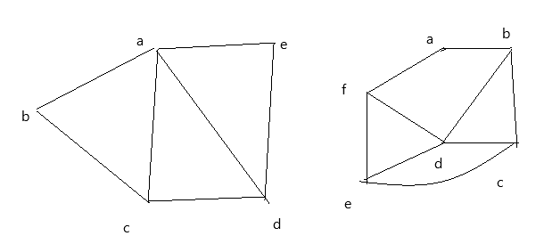 | [5M]
 | b) | What are spanning trees? Write and explain Prims algorithm.
14. | a) | Obtain principal disjunctive normal form of the following formula.  P˅(~P→(Q˅(~Q→R))) | [5M]
 | b) | Show the following equivalence without truth table.  (((P˄Q˄R)→C)˄(R→(P˅Q˅C)))(R˄(P↔Q))→C | [5M]
15. | a) | Prove that the following argument is valid  ∀x p(x) →~q(x)  ¬∃x ((r(x) ˅ s(x))˄ ¬q(x)  r(a)  ∴p(a) | [5M]
 | b) | For the following formulas let the universe be R. Translate each of the following sentence into a formula (using quantifiers)  - There is a largest number  - Every positive integer has a square root (do not use square root symbol use only multiplication) | [5M]
16. | a) | Let x={1,2,3} and f, g, h be functions from x to x given by f={(1,2),(2,3),(3,1)} g={(1,2),(2,1),(3,3)} h={(1,1),(2,2),(3,1)} Find fog, foh, fohog, goh | [5M]
 | b) | Write about partial ordering and total ordering relations. | [5M]
17. |  | Write short notes on:
 | a) | automatic theorem proving. | [3M]
 | b) | Rules of Inference. | [3M]
 | c) | Homomorphism. | [4M]
18. | a) | What is pigeon hole principle? What are its applications? | [5M]
 | b) | Find number of positive integer solutions of x+y+z =12. | [5M]

-- 00 -- 00 –

